**Terraform Day-06**

***Mohammed Rafiyoodin – 06-05-2024***

1) Create VPC

resource "aws_vpc" "main" {

  cidr_block       = "192.168.0.0/24"

  instance_tenancy = "default"

  tags = {

    Name = "project VPC"

  }

}

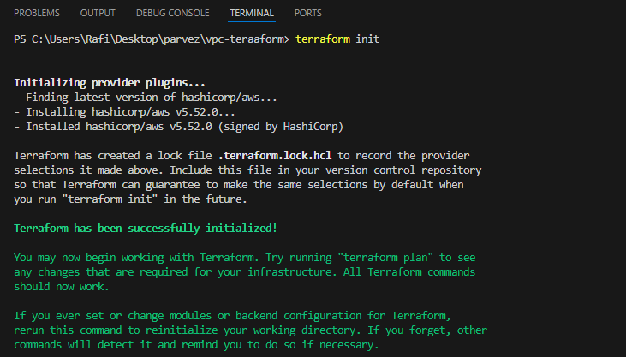

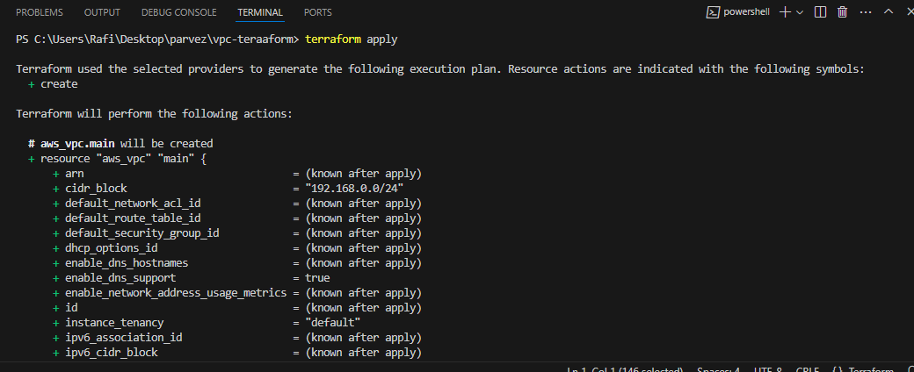

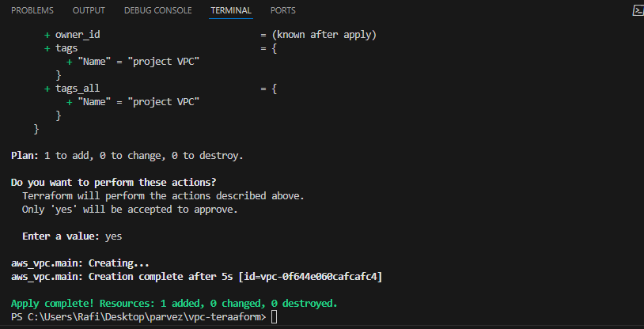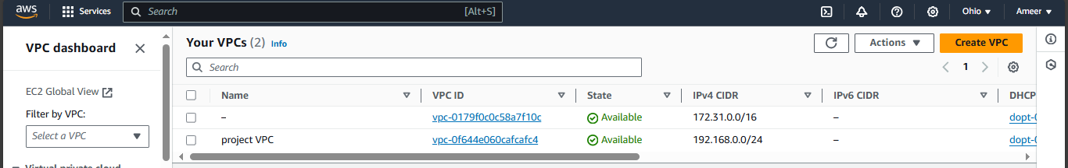

2) Create Internet gateway

# Internet Gateway

resource "aws_internet_gateway" "igw" {

  vpc_id = aws_vpc.main.id

  tags = {

    Name = "Project VPC IG"

  }

}

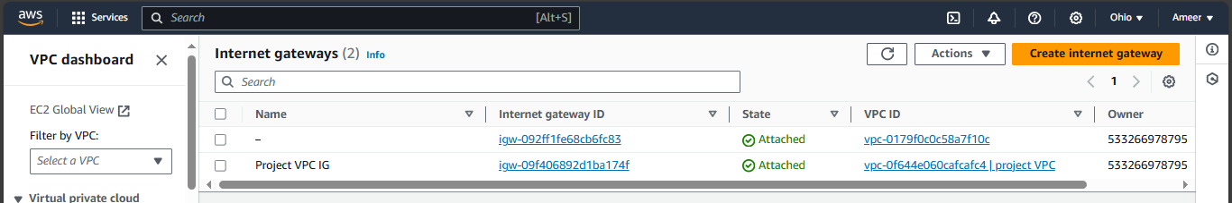

3) Create Custom Route Table

# Creating Route Table

resource "aws_route_table" "route" {

  vpc_id = aws_vpc.main.id

  route {

    cidr_block = "0.0.0.0/0"

    gateway_id = aws_internet_gateway.igw.id

  }

  tags = {

    Name = "Project VPC RT"

  }

}

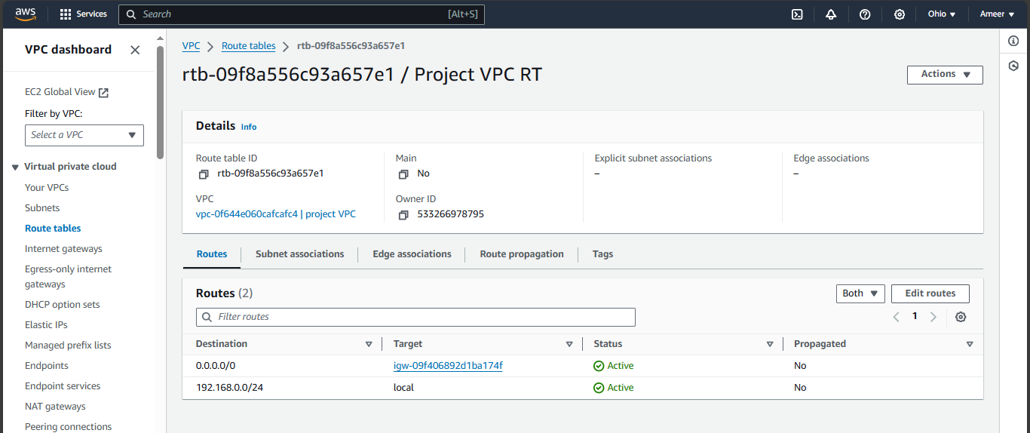

4) Create Subnet

}# Creating 1st my_subnet

resource "aws_subnet" "my_subnet" {

  vpc_id                  = aws_vpc.main.id

  cidr_block              = "192.168.0.0/24"

  availability_zone       = "us-east-2b"

  tags = {

    Name = "my_subnet"

  }

}

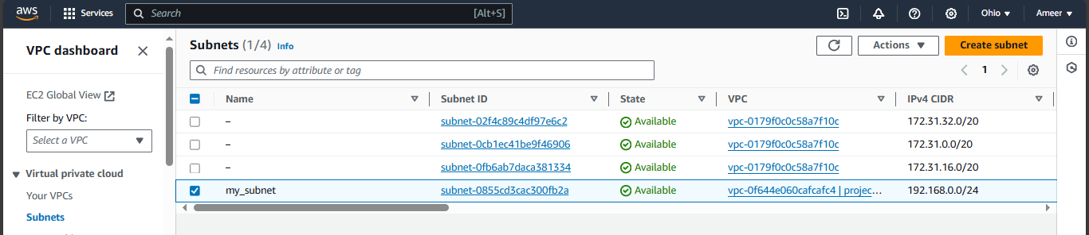

5) Associate subnet with Route Table

# Associating Route Table

resource "aws_route_table_association" "my_subnet_association" {

  subnet_id      = aws_subnet.my_subnet.id

  route_table_id = aws_route_table.route.id

}

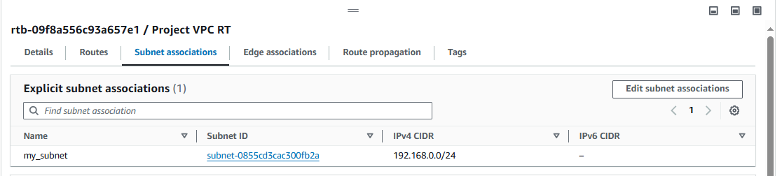

6) Create Security Group to allow port 22.80,443

# Creating Security Group

resource "aws_security_group" "Rafisg" {

  vpc_id = "${aws_vpc.main.id}"

  # Inbound Rules

  # HTTP access from anywhere

  ingress {

    from_port   = 80

    to_port     = 80

    protocol    = "tcp"

    cidr_blocks = ["0.0.0.0/0"]

  }

  # HTTPS access from anywhere

  ingress {

    from_port   = 443

    to_port     = 443

    protocol    = "tcp"

    cidr_blocks = ["0.0.0.0/0"]

  }

  # SSH access from anywhere

  ingress {

    from_port   = 22

    to_port     = 22

    protocol    = "tcp"

    cidr_blocks = ["0.0.0.0/0"]

  }

  # Outbound Rules

  # Internet access to anywhere

  egress {

    from_port   = 0

    to_port     = 0

    protocol    = "-1"

    cidr_blocks = ["0.0.0.0/0"]

  }

  tags = {

    Name = "Rafi_sg"

  }

}

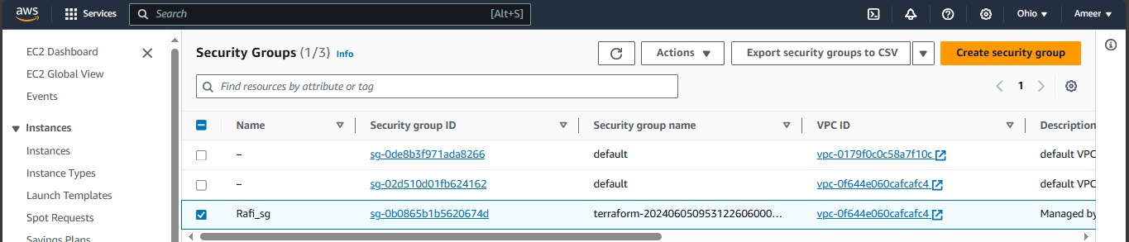

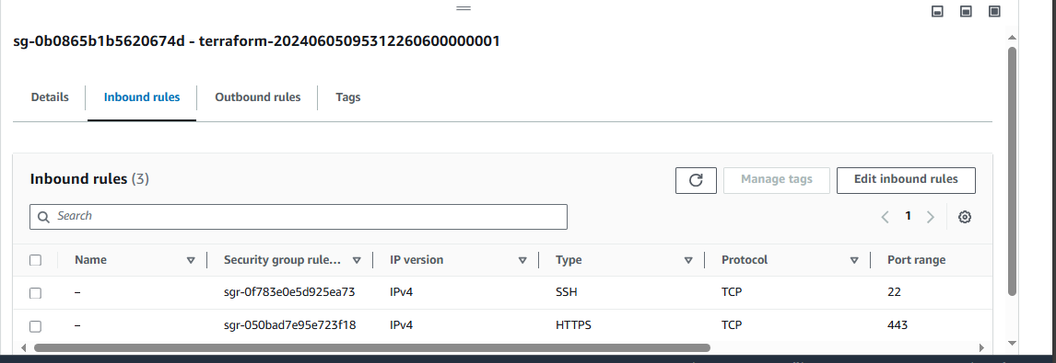

7) Create a network interface with an ip in the subnet that was created in step 4

resource "aws_network_interface" "project_interface" {

subnet_id = aws_subnet.my_subnet.id

private_ips = ["192.168.0.25"]

tags = {

name = "MY_NETWORK_INTERFACE"

}

}

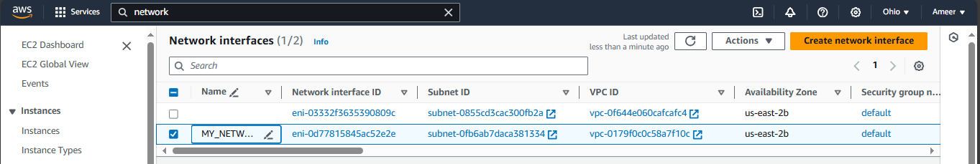

8) Assign an elastic IP to the network interface created in step 7

resource "aws_eip" "my_ip" {

vpc = true

}

resource "aws_eip_association" "my_eip_association" {

    network_interface_id = aws_network_interface.project_interface.id

    allocation_id = aws_eip.my_ip.id

}

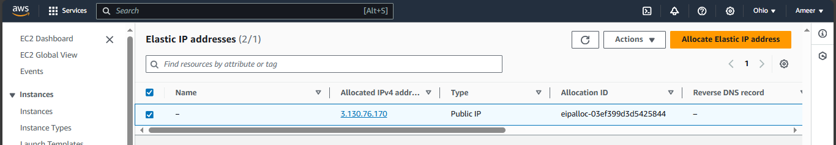

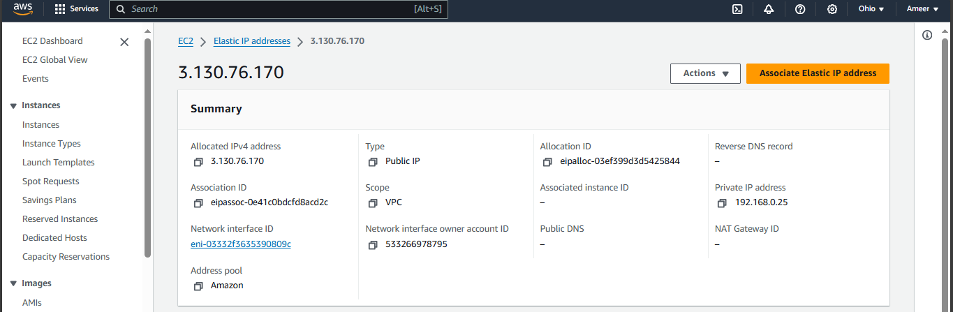

9) Create Ubuntu server and install/enable apache2

resource "aws_instance" "ubuntu_image" {

    ami = "ami-09040d770ffe2224f"

    instance_type = "t2.micro"

    subnet_id = aws_subnet.my_subnet.id

    vpc_security_group_ids = [aws_security_group.Rafisg.id]

    user_data = <<-EOF

                 #!/bin/bash

                 apt-get update

                 apt-get install -y apache2

                 systemctl enable apache2

                 systemctl start apache2

                 EOF

}

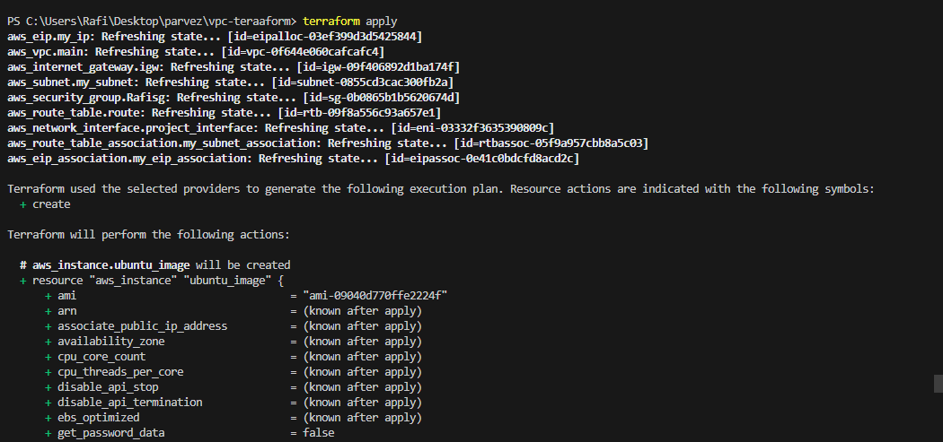

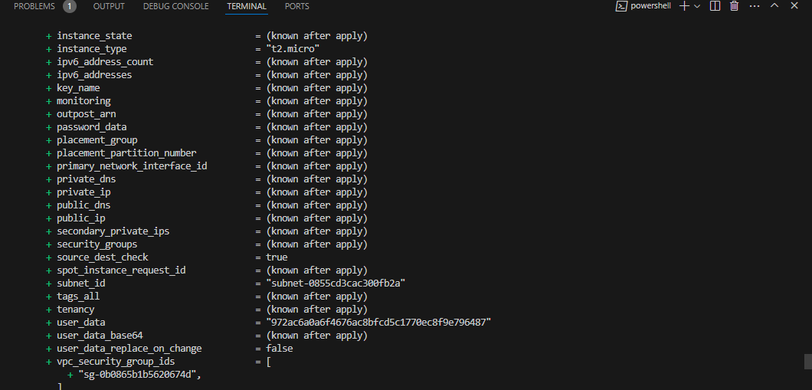

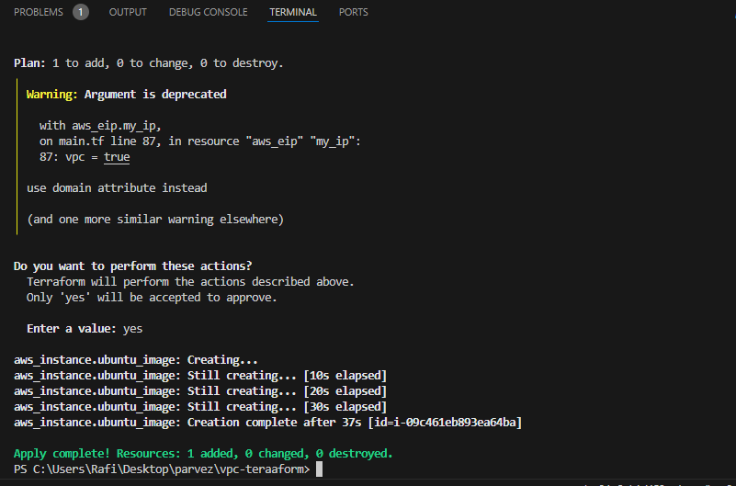

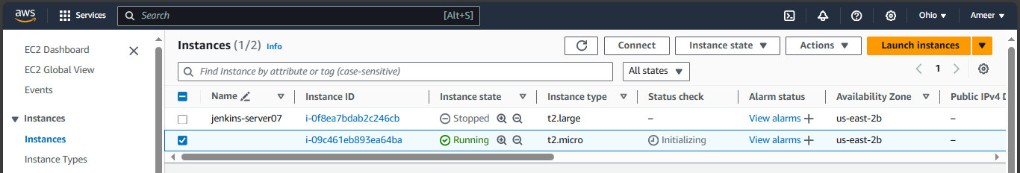

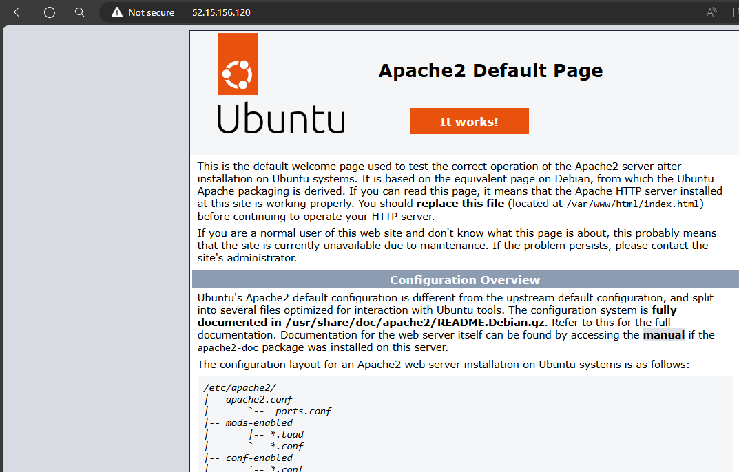

**Configure s3 as backend and dynamo db locking for multi user execution.**

#Create s3 using terraform

resource "aws_s3_bucket" "s3_bucket" {

    bucket = "s3-backend-babji123"

    acl = "private"

}

# Create dynamo db using terraform

resource "aws_dynamodb_table" "dynamodb-terraform-state-lock" {

  name = "terraform-state-dynamoDB"

  hash_key = "LockID"

  read_capacity = 20

  write_capacity = 20

  attribute {

    name = "LockID"

    type = "S"

  }

}

#S3 as backend for terraform.tfstate file

terraform {

  backend "s3" {

    bucket = "s3-backend-babji123"

    dynamodb_table = "terraform-state-dynamoDB"

    key    = "terraform.tfstate"

    region = "us-east-2"

  }

}

**Created S3 Bucket**

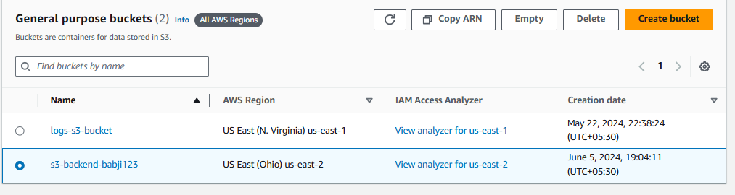

**Created dynamoDB**

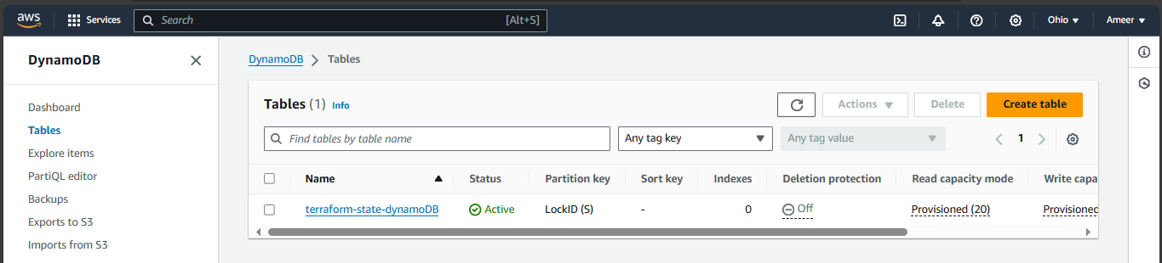

**Created S3 as backend for terraform.tfstate.file**

